연구윤리 과제 8주차

교수님 지시 사항

* Weight & bias API를 이용하여 관련 가중치 트랙킹
* 기본 데이터의 전처리 및 데이량 증가
* Train Loss: 0.101, Valid Loss: 0.155518, Accuracy: 0.95
* Train Loss: 0.072, Valid Loss: 0.147096, Accuracy: 0.96
* Train Loss: 0.024, Valid Loss: 0.153561, Accuracy: 0.95
* Waiting for W&B process to finish... **(success).**

### Run history:

|  |  |
| --- | --- |
| train/epoch | ▁▁▁▁▂▂▂▂▂▃▃▃▃▃▃▄▄▄▄▄▅▅▅▅▅▅▆▆▆▆▆▇▇▇▇▇▇███ |
| train/example_ct | ▁▁▁▁▂▂▂▂▂▃▃▃▃▃▃▄▄▄▄▄▅▅▅▅▅▅▆▆▆▆▆▇▇▇▇▇▇███ |
| train/train_loss | █▅▃▄▃▂▂▃▂▂▂▂▂▂▂▁▂▁▂▂▁▁▁▁▁▁▁▁▁▁▁▁▁▁▁▁▁▁▁▁ |
| val/val_accuracy | ▁▂▅▆▆▇▇▇█▇ |
| val/val_loss | █▅▄▃▂▂▁▁▁▁ |

|  |  |
| --- | --- |
| test_accuracy | 0.8 |
| train/epoch | 10.0 |
| train/example_ct | 120000 |
| train/train_loss | 0.02394 |
| val/val_accuracy | 0.9525 |
| val/val_loss | 0.15356 |

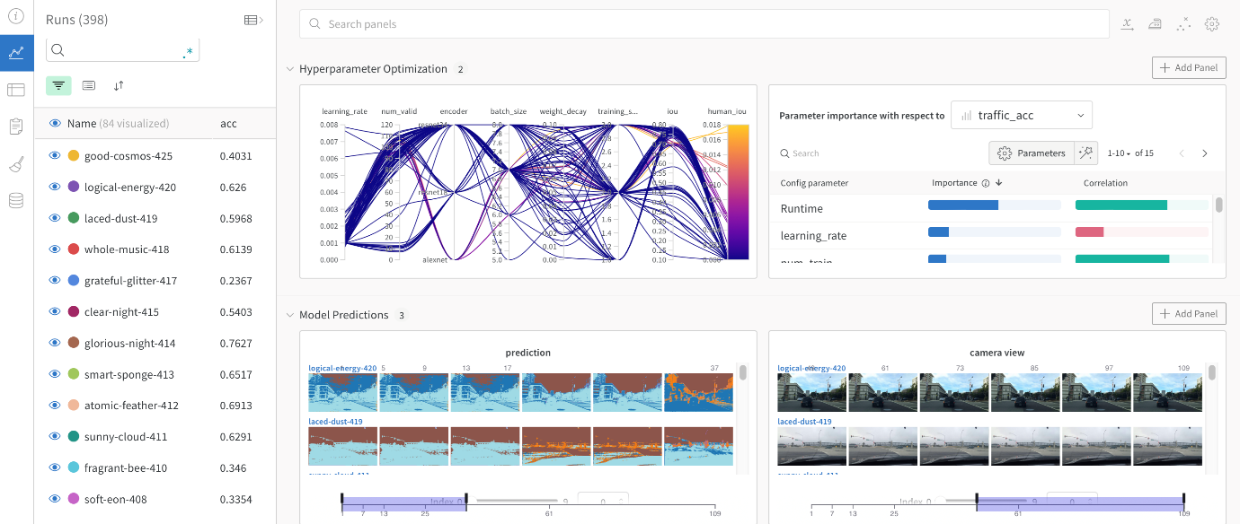

2. 데이터 전처리 및 증량

|  |  |
| --- | --- |
| Label | Q'ty |
| Ashaft | 1535 |
| Aoil | 1494 |
| flange | 1434 |
| Abearing | 1207 |
| AGear | 954 |
| stator | 937 |
| bearing_motor | 742 |
| Motor casing | 734 |
| Gear casing | 726 |
| stator_inlet | 712 |
| Amotor | 618 |
| stator_shaft | 605 |
| outlet | 597 |
| bypass | 591 |
| Gear | 550 |
| bearing_gear | 496 |
| Motor_up | 933 |
| lipseal | 343 |
| other | 189 |

|  |  |
| --- | --- |
| train | test |
| (13376, 2) | (1487, 2)) |

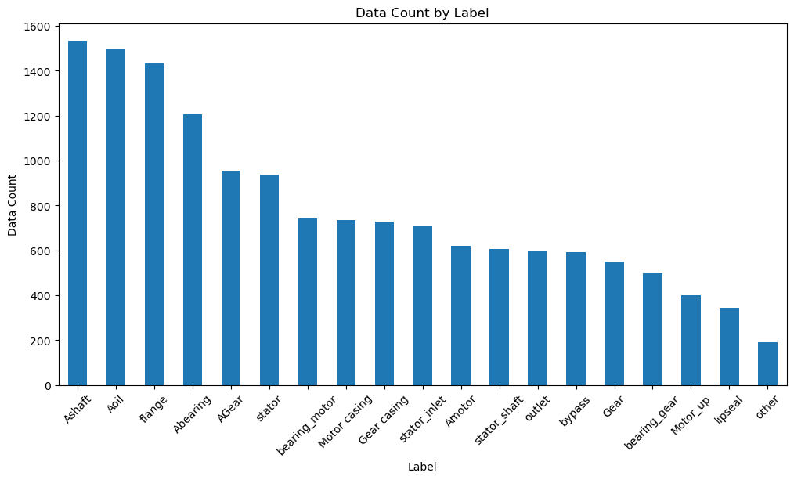

|  |  |  |  |
| --- | --- | --- | --- |
| **train** | validating |  |  |
| **Found 11899 images belonging to 19 classes.** | | | |
| **Found 2964 images belonging to 19 classes.** | | | |

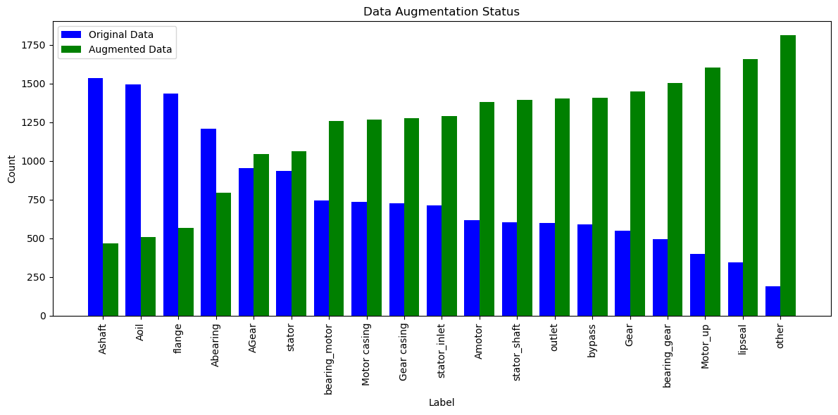

|  |  |
| --- | --- |
| model = tf.keras.Sequential([ | |
| base_model, | |
| tf.keras.layers.GlobalAveragePooling2D(), | |
| tf.keras.layers.Dense(128, activation='relu'), | |
| tf.keras.layers.Dense(128, activation='relu'), | |
| tf.keras.layers.Dense(num_classes,activation='softmax') | |
| ]) |  |
| Model trained in 36137.2 sec | | |
| Validation Accuracy: [0.9712, 0.9753, 0.9737, 0.975, 0.9699, 0.9783, 0.9761, 0.9739, 0.9797, 0.9762, 0.9814, 0.9807, 0.9801, 0.9813, 0.982, 0.9762, 0.9789, 0.9803, 0.9722, 0.9795] | | |

